Name _______________________________ Date: _____________
T: To reflect on the Miracle of Jesus feeding 5000
Imagine you are the boy in the story.
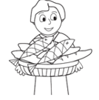 | What would you say to Jesus when you gave him the bread and fish?  _______________________________  _______________________________  _______________________________  _______________________________
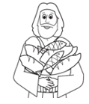 | What do you think Jesus would say to you?  _______________________________  _______________________________  _______________________________  _______________________________

Imagine you were one of the people picking up the leftover food.
(draw a picture of you) | How would you feel when you realised there had been MORE than enough food for everyone?  _______________________________  _______________________________  _______________________________  _______________________________

Jesus calls us to care for others
How do people today care for people who have no food?
____________________________________________________________________________________________________________________________________________________________________________________________

